**CSC**

**LIBRARY MANAGEMENT SYSTEM USING PYTHON GUI AND MYSQL**

**PREPARED BY**

**Aisvarryaa N**

**GUIDED BY, CENTER HEAD,**

Priyadharshini.P MCA Navamani.S Msc.,Mphil.,

**AIM:**

To develop a Library Management System using python GUI and MYSQL.

**PROCEDURE:**

STEP 1: Start the program

STEP 2: Login by entering the necessary credentials in the “login page”, Once logged in successfully a message box appears stating that “you have successfully logged in”. Else, an error message is popped up stating that “invalid login”.

STEP 3: Once the login is done successfully, the login page directs to the “menu page.”

STEP 4: The menu page contains a list of options like:

1. Add book – Adding a book
2. Delete book – Deleting a book
3. View book – List the number of books is available
4. Return book – Return the book
5. Issue book – Issuing the book

From above options user can select any options that user needs to pursue. Once it is done, They can logout.

STEP 5: Stop the program

**#LOGIN PAGE**

from tkinter import*

from tkinter import messagebox

import mysql.connector

mydb = mysql.connector.connect(host ="localhost",user ="root",

password = "Aishu106#206$",database="library")

mycursor = mydb.cursor()

**#BACKGROUND IMAGE**

root=Tk()

root.title("Login page")

photo=PhotoImage(file="3.gif")

w=Label(root,image=photo)

w.pack()

root.geometry("700x410")

root.resizable(False,False)

#####################################################################

**#ICON IMAGE**

image_icon=PhotoImage(file="icon.gif")

root.iconphoto(False,image_icon)

#####################################################################

**#USERNAME AND PASSWORD:**

login_label = Label(root, text="LIBRARY MANAGEMENT SYSTEM",bg='black',

fg="gold", font=("Courier",25,'bold'))

login_label.place(x=100,y=50)

username=Label(root,text="USERNAME",bg='black',fg='gold',

font=('Courier',15,'bold'))

username.place(x=150,y=150)

password=Label(root,text="PASSWORD",bg='black',fg='gold',

font=('Courier',15,'bold'))

password.place(x=150,y=200)

username_entry=Entry(root,width=20,bg='black',fg='gold',

font=('Courier',15))

username_entry.place(x=350,y=150)

password_entry=Entry(root,width=20,bg='black',show="*",fg='gold',

font=('Courier',15))

password_entry.place(x=350,y=200)

#####################################################################

**#LOGIN BUTTON**

def login():

username = "aishu"

password = "aishu123"

if username_entry.get()==username and password_entry.get()==password:

messagebox.showinfo(title="Login Successful!", message="You successfully logged in.")

root.destroy()

import menu

else:

messagebox.showerror(title="Error", message="Invalid login.")

login=Button(root,text="LOGIN",bg='black',fg='gold',

font=('Courier',15,'bold'),activebackground="gold",activeforeground=

"black",command=login)

login.place(x=320,y=250)

######################################################################

**#EYE IMAGE OPEN AND CLOSE**

button_mode=True

def hide():

global button_mode

if button_mode:

eyebutton.config(image=closeeye,activebackground="gold")

password_entry.config(show="*")

button_mode=False

else:

eyebutton.config(image=openeye,activebackground="gold")

password_entry.config(show="")

button_mode=True

closeeye=PhotoImage(file="closeeye.gif")

openeye=PhotoImage(file="openeye.gif")

eyebutton=Button(root,image=openeye,bg='gold',fg='gold',bd=0,command=hide)

eyebutton.place(x=600,y=200)

root.mainloop()

**#MENU PAGE**

from tkinter import*

from tkinter import messagebox

import mysql.connector

from tkinter import *

mydb = mysql.connector.connect(host ="localhost",user ="root",

password = "Aishu106#206$",database="library")

mycursor = mydb.cursor()

**#BACKGROUND IMAGE**

root=Tk()

root.title("Menu page")

photo=PhotoImage(file="5.gif")

w=Label(root,image=photo)

w.pack()

root.geometry("700x410")

root.resizable(False,False)

######################################################################

**#ICON IMAGE**

image_icon=PhotoImage(file="icon.gif")

root.iconphoto(False,image_icon)

######################################################################

**#ITEM TO BE DISPLAYED**

def addpage(): **#ADD PAGE**

root.destroy()

import add

btn1 = Button(root,text="ADD BOOKS",bg='black',

fg='gold',font=('Courier',15,'bold'),activebackground="gold",

activeforeground="black",command=addpage)

btn1.place(x=90,y=90)

def deletepage(): **#DELETE PAGE**

root.destroy()

import delete

btn2 = Button(root,text="DELETE BOOKS",bg='black',

fg='gold',font=('Courier',15,'bold'),activebackground="gold",

activeforeground="black",command=deletepage)

btn2.place(x=420,y=90)

def viewpage(): **#VIEW PAGE**

root.destroy()

import view

btn3 = Button(root,text="VIEW BOOKS",bg='black',

fg='gold',font=('Courier',15,'bold'),activebackground="gold",

activeforeground="black",command=viewpage)

btn3.place(x=90,y=170)

def issuepage(): **#ISSUE PAGE**

root.destroy()

import issue

btn4 = Button(root,text="ISSUED BOOKS",bg='black',

fg='gold',font=('Courier',15,'bold'),activebackground="gold",

activeforeground="black",command=issuepage)

btn4.place(x=420,y=170)

def returnpage(): **#RETURN PAGE**

root.destroy()

import Return

btn5 = Button(root,text="RETURN BOOKS",bg='black',

fg='gold',font=('Courier',15,'bold'),activebackground="gold",

activeforeground="black",command=returnpage)

btn5.place(x=250,y=250)

def homepage(): **#BACK TO LOGIN PAGE**

root.destroy()

import loginpage

btn6=Button(root,text="LOGOUT",bg='black',fg='gold',font=('Courier',15,'bold'),activebackground="gold",activeforeground="black",command=homepage)

btn5.place(x=300,y=350)

root.mainloop()

**#ADD PAGE**

from tkinter import*

from tkinter import messagebox

from tkinter import messagebox

import mysql.connector

mydb = mysql.connector.connect(host ="localhost",user ="root",password = "Aishu106#206$",database="library")

mycursor =mydb.cursor()

def bookregister(): **#ADDING A BOOK INTO THE DATABASE**

bid = label_1_entry.get()

title = label_2_entry.get()

author = label_3_entry.get()

status = label_4_entry.get()

status = status.lower()

dept = label_5_entry.get()

if (bid ==""or title==""or author==""or status=="" or dept==""):

messagebox.showinfo('Error', "Empty data cant be inserted")

else:

insertbooks = "insert into books values('" + bid +"','"+title+"','"+author+"','"+status+"','"+dept+"')"

try:

mycursor.execute(insertbooks)

mydb.commit()

messagebox.showinfo('Success',"Book added successfully")

import menu

except:

messagebox.showinfo("Error","Can't add data into Database")

def addBook():

global label_1_entry, label_2_entry, label_3_entry, label_4_entry,label_5_entry, mydb, mycursor, books, root

**#BACKGROUND IMAGE**

root=Tk()

root.title("Add Book")

photo=PhotoImage(file="5.gif")

w=Label(root,image=photo)

w.pack()

root.geometry("700x410")

root.resizable(False,False)

######################################################################

**#ICON IMAGE**

image_icon=PhotoImage(file="icon.gif")

root.iconphoto(False,image_icon)

######################################################################

**#LABELS**

login_label = Label(root, text="ADD BOOKS", bg='black', fg="gold", font=("Courier",20,'bold'))

login_label.place(x=260,y=10)

label_1=Label(root,text="BOOK ID",bg='black', fg='gold',

font=('Courier',13,'bold'))

label_1.place(x=60,y=80)

label_2=Label(root,text="TITLE",bg='black', fg='gold',

font=('Courier',13,'bold'))

label_2.place(x=60,y=130)

label_3=Label(root,text="AUTHOR",bg='black', fg='gold',

font=('Courier',13,'bold'))

label_3.place(x=60,y=180)

label_4=Label(root,text="STATUS(Avail or Issued)",bg='black',

fg='gold', font=('Courier',13,'bold'))

label_4.place(x=60,y=230)

label_5=Label(root,text="DEPARTMENT",bg='black', fg='gold',

font=('Courier',13,'bold'))

label_5.place(x=60,y=280)

label_1_entry=Entry(root,width=20,bg='black',

fg='gold',font=('Courier',13))

label_1_entry.place(x=380,y=80)

label_2_entry=Entry(root,width=20,bg='black',

fg='gold',font=('Courier',13))

label_2_entry.place(x=380,y=130)

label_3_entry=Entry(root,width=20,bg='black',

fg='gold',font=('Courier',13))

label_3_entry.place(x=380,y=180)

label_4_entry=Entry(root,width=20,bg='black',

fg='gold',font=('Courier',13))

label_4_entry.place(x=380,y=230)

label_5_entry=Entry(root,width=20,bg='black',

fg='gold',font=('Courier',13))

label_5_entry.place(x=380,y=280)

######################################################################

**#BUTTONS**

submit=Button(root,text="SUBMIT",bg='black',fg='gold',

font=('Courier',15,'bold'),activebackground="gold",activeforeground=

"black",command=bookregister)

submit.place(x=200,y=340)

def menupage():

root.destroy()

import menu1

quit1=Button(root,text="BACK",bg='black',fg='gold',

font=('Courier',15,'bold'),activebackground="gold",activeforeground=

"black",command=menupage)

quit1.place(x=400,y=340)

root.mainloop()

**#VIEW PAGE**

from tkinter import *

from tkinter import messagebox

import mysql.connector

mydb = mysql.connector.connect(host ="localhost",user ="root",

password = "Aishu106#206$",database="library")

mycursor = mydb.cursor()

**#BACKGROUND IMAGE**

root=Tk()

root.title("View Book")

photo=PhotoImage(file="5.gif")

w=Label(root,image=photo)

w.pack()

root.geometry("700x410")

root.resizable(False,False)

######################################################################

**#ICON IMAGE**

image_icon=PhotoImage(file="icon.gif")

root.iconphoto(False,image_icon)

######################################################################

**#LABELS**

def deptpage():

root.destroy()

import departments

view=Button(root, text="DEPARTMENTS", bg='black', fg="gold",

font=("Courier",20,'bold'),activebackground="gold",activeforeground=

“black",command=deptpage)

view.place(x=260,y=150)

**#DEPARTMENTS PAGE**

from tkinter import *

import mysql.connector

mydb = mysql.connector.connect(host ="localhost",user ="root",

password = "Aishu106#206$",database="library")

mycursor = mydb.cursor()

**#BACKGROUND IMAGE**

root=Tk()

root.title("Department page")

photo=PhotoImage(file="5.gif")

w=Label(root,image=photo)

w.pack()

root.geometry("700x410")

root.resizable(False,False)

#############################################################

**#ICON IMAGE**

image_icon=PhotoImage(file="icon.gif")

root.iconphoto(False,image_icon)

##############################################################

**#ITEM TO BE DISPLAYED**

def csepage(): **#CSE PAGE**

root.destroy()

import cse

btn1 = Button(root,text="CSE DEPT",bg='black',

fg='gold',font=('Courier',15,'bold'),activebackground="gold",

activeforeground="black",command=csepage)

btn1.place(x=90,y=90)

def itpage(): **#IT PAGE**

root.destroy()

import it

btn2 = Button(root,text="IT DEPT",bg='black',

fg='gold',font=('Courier',15,'bold'),activebackground="gold",

activeforeground="black",command=itpage)

btn2.place(x=420,y=90)

def ecepage(): **#ECE PAGE**

root.destroy()

import ece

btn3 = Button(root,text="ECE DEPT",bg='black',

fg='gold',font=('Courier',15,'bold'),activebackground="gold",

activeforeground="black",command=ecepage)

btn3.place(x=90,y=170)

def eeepage(): **#EEE PAGE**

root.destroy()

import eee

btn4 = Button(root,text="EEE DEPT",bg='black',

fg='gold',font=('Courier',15,'bold'),activebackground="gold",

activeforeground="black",command=eeepage)

btn4.place(x=420,y=170)

def eipage(): **#E&I PAGE**

root.destroy()

import ei

btn5 = Button(root,text="E&I DEPT",bg='black',

fg='gold',font=('Courier',15,'bold'),activebackground="gold",

activeforeground="black",command=eipage)

btn5.place(x=250,y=250)

root.mainloop()

**#CSE DEPARTMENT PAGE**

from tkinter import *

from tkinter import messagebox

import mysql.connector

mydb = mysql.connector.connect(host ="localhost",user = "root",

password = "Aishu106#206$",database="library")

mycursor = mydb.cursor()

**#BACKGROUND IMAGE**

root=Tk()

root.title("View Book")

photo=PhotoImage(file="5.gif")

w=Label(root,image=photo)

w.pack()

root.geometry("700x410")

root.resizable(False,False)

######################################################################

**#ICON IMAGE**

image_icon=PhotoImage(file="icon.gif")

root.iconphoto(False,image_icon)

######################################################################

**#LABELS**

login_label = Label(root, text="CSE BOOKS", bg='black', fg="gold", font=("Courier",20,'bold'))

login_label.place(x=260,y=50)

Label(root, text="%-10s%-25s%-25s%-20s%

-10s"%('BID','TITLE','AUTHOR','STATUS','DEPT'),bg='black',fg='gold',

font=("Courier",10,'bold')).place(x=5,y=100)

sql = "select * from books where dept='cse'"

mycursor.execute(sql)

results=mycursor.fetchall()

for row in results:

bid=row[0]

title=row[1]

author=row[2]

status=row[3]

dept=row[4]

Label(root,text="%-10s%-25s%-25s%-20s%

-10s"%(row[0],row[1],row[2],row[3],row[4]),bg='black',

fg='gold',font=("Courier",10,'bold')).place(x=10,y=140)

print("bid= %s,title= %s,author= %s,status= %s,

dept= %s"%(bid,title,author,status,dept))

######################################################################

**#BUTTONS:**

def menupage():

root.destroy()

import menu

quit1=Button(root,text="BACK TO MENU",bg='black',fg='gold',

font=('Courier',15,'bold'),activebackground="gold",activeforeground=

“black",command=menupage)

quit1.place(x=270,y=340)

**#IT DEPARTMENT PAGE**

from tkinter import *

from tkinter import messagebox

import mysql.connector

mydb = mysql.connector.connect(host ="localhost",user ="root",

password = "Aishu106#206$",database="library")

mycursor = mydb.cursor()

**#BACKGROUND IMAGE**

root=Tk()

root.title("View Book")

photo=PhotoImage(file="5.gif")

w=Label(root,image=photo)

w.pack()

root.geometry("700x410")

root.resizable(False,False)

######################################################################

**#ICON IMAGE**

image_icon=PhotoImage(file="icon.gif")

root.iconphoto(False,image_icon)

######################################################################

**#LABELS**

login_label = Label(root, text="IT BOOKS", bg='black', fg="gold", font=("Courier",20,'bold'))

login_label.place(x=260,y=50)

Label(root, text="%-10s%-25s%-25s%-20s%

-10s"%('BID','TITLE','AUTHOR','STATUS','DEPT'),bg='black',fg='gold',

font=("Courier",10,'bold')).place(x=5,y=100)

sql = "select * from books where dept='it'"

mycursor.execute(sql)

results=mycursor.fetchall()

for row in results:

bid=row[0]

title=row[1]

author=row[2]

status=row[3]

dept=row[4]

Label(root,text="%-10s%-25s%-25s%-20s%

-10s"%(row[0],row[1],row[2],row[3],row[4]) ,bg='black',

fg='gold',font=("Courier",10,'bold')).place(x=10,y=140)

print("bid= %s,title= %s,author= %s,status= %s,

dept=%s"%(bid,title,author,status,dept))

######################################################################

**#BUTTONS**

def menupage():

root.destroy()

import menu1

quit1=Button(root,text="BACK TO MENU",bg='black',fg='gold',

font=('Courier',15,'bold'),activebackground="gold",

activeforeground="black",command=menupage)

quit1.place(x=300,y=340)

**#ECE DEPARTMENT PAGE**

from tkinter import *

from tkinter import messagebox

import mysql.connector

mydb = mysql.connector.connect(host ="localhost",user ="root",

password = "Aishu106#206$",database="library")

mycursor = mydb.cursor()

**#BACKGROUND IMAGE**

root=Tk()

root.title("View Book")

photo=PhotoImage(file="5.gif")

w=Label(root,image=photo)

w.pack()

root.geometry("700x410")

root.resizable(False,False)

######################################################################

**#ICON IMAGE**

image_icon=PhotoImage(file="icon.gif")

root.iconphoto(False,image_icon)

######################################################################

**#LABELS**

login_label = Label(root, text="ECE BOOKS", bg='black', fg="gold", font=("Courier",20,'bold'))

login_label.place(x=260,y=50)

Label(root, text="%-10s%-25s%-25s%-20s%

-10s"%('BID','TITLE','AUTHOR','STATUS','DEPT'),bg='black',fg='gold',

font=("Courier",10,'bold')).place(x=5,y=100)

sql = "select * from books where dept='ece'"

mycursor.execute(sql)

results=mycursor.fetchall()

for row in results:

bid=row[0]

title=row[1]

author=row[2]

status=row[3]

dept=row[4]

Label(root,text="%-10s%-25s%-25s%-20s%

-10s"%(row[0],row[1],row[2],row[3],row[4]) ,bg='black',

fg='gold',font=("Courier",10,'bold')).place(x=10,y=140)

print("bid= %s,title= %s,author= %s,status= %s,dept=

%s"%(bid,title,author,status,dept))

######################################################################

**#BUTTON**

def menupage():

root.destroy()

import menu1

quit1=Button(root,text="BACK TO MENU",bg='black',fg='gold',

font=('Courier',15,'bold'),activebackground="gold",activeforeground=

“black",command=menupage)

quit1.place(x=270,y=340)

**#EEE DEPARTMENT PAGE**

from tkinter import *

from tkinter import messagebox

import mysql.connector

mydb = mysql.connector.connect(host ="localhost",user ="root",

password = "Aishu106#206$",database="library")

mycursor = mydb.cursor()

**#BACKGROUND IMAGE**

root=Tk()

root.title("View Book")

photo=PhotoImage(file="5.gif")

w=Label(root,image=photo)

w.pack()

root.geometry("700x410")

root.resizable(False,False)

######################################################################

**#ICON IMAGE**

image_icon=PhotoImage(file="icon.gif")

root.iconphoto(False,image_icon)

######################################################################

**#LABELS**

login_label = Label(root, text="EEE BOOKS", bg='black', fg="gold", font=("Courier",20,'bold'))

login_label.place(x=260,y=50)

Label(root, text="%-10s%-25s%-25s%-20s%-10s"%('BID','TITLE','AUTHOR','STATUS','DEPT'),bg='black',fg='gold',font=("Courier",10,'bold')).place(x=5,y=100)

sql = "select * from books where dept='eee'"

mycursor.execute(sql)

results=mycursor.fetchall()

for row in results:

bid=row[0]

title=row[1]

author=row[2]

status=row[3]

dept=row[4]

Label(root,text="%-10s%-25s%-25s%-20s%-10s"%(row[0],row[1],row[2],row[3],row[4]) ,bg='black', fg='gold',font=("Courier",10,'bold')).place(x=10,y=140)

print("bid= %s,title= %s,author= %s,status= %s,dept= %s"%(bid,title,author,status,dept))

######################################################################

**#BUTTON**

def menupage():

root.destroy()

import menu1

quit1=Button(root,text="BACK TO MENU",bg='black',fg='gold',

font=('Courier',15,'bold'),activebackground="gold",activeforeground=

"black",command=menupage)

quit1.place(x=270,y=340)

**#E&I DEPARTMENT PAGE**

from tkinter import *

from tkinter import messagebox

import mysql.connector

mydb = mysql.connector.connect(host ="localhost",user ="root",

password = "Aishu106#206$",database="library")

mycursor = mydb.cursor()

**#BACKGROUND IMAGE**

root=Tk()

root.title("View Book")

photo=PhotoImage(file="5.gif")

w=Label(root,image=photo)

w.pack()

root.geometry("700x410")

root.resizable(False,False)

######################################################################

**#ICON IMAGE**

image_icon=PhotoImage(file="icon.gif")

root.iconphoto(False,image_icon)

######################################################################

**#LABELS**

login_label = Label(root, text="E&I BOOKS", bg='black', fg="gold",

font=("Courier",20,'bold'))

login_label.place(x=260,y=50)

Label(root, text="%-10s%-25s%-25s%-20s%

-10s"%('BID','TITLE','AUTHOR','STATUS','DEPT'),bg='black',fg='gold',

font=("Courier",10,'bold')).place(x=5,y=100)

sql = "select * from books where dept='ei'"

mycursor.execute(sql)

results=mycursor.fetchall()

for row in results:

bid=row[0]

title=row[1]

author=row[2]

status=row[3]

dept=row[4]

Label(root,text="%-10s%-25s%-25s%-20s%

-10s"%(row[0],row[1],row[2],row[3],row[4]) ,bg='black’,

fg='gold',font=("Courier",10,'bold')).place(x=10,y=140)

print("bid= %s,title= %s,author= %s,status= %s,

dept= %s"%(bid,title,author,status,dept))

######################################################################**#BUTTON**

def menupage():

root.destroy()

import menu1

quit1=Button(root,text="BACK TO MENU",bg='black',fg='gold',

font=('Courier',15,'bold'),activebackground="gold",activeforeground=

"black",command=menupage)

quit1.place(x=270,y=340)

**#ISSUE BOOK PAGE**

from tkinter import*

from tkinter import messagebox

import mysql.connector

from tkinter import *

mydb = mysql.connector.connect(host ="localhost",user ="root",

password = "Aishu106#206$",database="library")

mycursor = mydb.cursor()

######################################################################

**#ISSUE BOOK**

def issuebk():

bid = label_1_entry.get()

if(bid!=" "):

mycursor.execute("select status from books where bid=%d"%(int(bid)))

myresult=mycursor.fetchone()

c=int(myresult[0])

c=c-1

print("count=",c)

mycursor.execute("update books set status='%s' where bid=%d"%(str(c),int(bid)))

mydb.commit()

messagebox.showinfo('Success',"Status updated successsfully")

root.destroy()

else:

messagebox.showinfo('Eror',"Please enter the book ID")

**#BACKGROUND IMAGE**

root=Tk()

root.title("Issue Book")

photo=PhotoImage(file="5.gif")

w=Label(root,image=photo)

w.pack()

root.geometry("700x410")

root.resizable(False,False)

**#ICON IMAGE**

image_icon=PhotoImage(file="icon.gif")

root.iconphoto(False,image_icon)

######################################################################

**#LABELS**

login_label = Label(root, text="ISSUE BOOK", bg='black', fg="gold", font=("Courier",20,'bold'))

login_label.place(x=260,y=50)

label_1=Label(root,text="BOOK ID",bg='black', fg='gold', font=('Courier',15,'bold'))

label_1.place(x=120,y=200)

label_1_entry=Entry(root,width=20,bg='black', fg='gold',font=('Courier',15))

label_1_entry.place(x=340,y=200)

######################################################################

**#BUTTONS**

issue=Button(root,text="ISSUE",bg='black',fg='gold',

font=('Courier',15,'bold'),activebackground="gold",activeforeground=

"black",command=issuebk)

issue.place(x=200,y=340)

def menupage():

root.destroy()

import menu1

quit1=Button(root,text="QUIT",bg='black',fg='gold',

font=('Courier',15,'bold'),activebackground="gold",activeforeground=

"black",command=menupage)

quit1.place(x=400,y=340)

**#RETURN BOOK PAGE**

from tkinter import*

from tkinter import messagebox

import mysql.connector

from tkinter import*

mydb = mysql.connector.connect(host ="localhost",user = "root",

password = "Aishu106#206$",database="library")

mycursor = mydb.cursor()

######################################################################**#RETURN BOOK**

def returnbk():

bid = label_1_entry.get()

if (bid!=""):

mycursor.execute("select status from books where bid=%d"%(int(bid)))

myresult=mycursor.fetchone()

c=int(myresult[0])

c=c+1

print("count=",c)

mycursor.execute("update books set status='%s' where bid=%d"%(str(c),int(bid)))

mydb.commit()

messagebox.showinfo('Success',"Status updated successsfully")

root.destroy()

else:

messagebox.showinfo('Eror',"Please enter the book ID")

**#BACKGROUND IMAGE**

root=Tk()

root.title("Return Book")

photo=PhotoImage(file="5.gif")

w=Label(root,image=photo)

w.pack()

root.geometry("700x410")

root.resizable(False,False)

######################################################################

**#ICON IMAGE**

image_icon=PhotoImage(file="icon.gif")

root.iconphoto(False,image_icon)

######################################################################

**#LABELS**

login_label = Label(root, text="RETURN BOOK", bg='black', fg="gold",

font=("Courier",20,'bold'))

login_label.place(x=260,y=50)

label_1=Label(root,text="BOOK ID",bg='black', fg='gold',

font=('Courier',15,'bold'))

label_1.place(x=150,y=200)

label_1_entry=Entry(root,width=20,bg='black',fg='gold',

font=('Courier',15))

label_1_entry.place(x=340,y=200)

######################################################################

**#BUTTONS**

submit=Button(root,text="RETURN",bg='black',fg='gold',

font=('Courier',15,'bold'),activebackground="gold",activeforeground=

"black",command=returnbk)

submit.place(x=200,y=340)

def menupage():

root.destroy()

import menu1

quit1=Button(root,text="QUIT",bg='black',fg='gold',

font=('Courier',15,'bold'),activebackground="gold",activeforeground=

"black",command=menupage)

quit1.place(x=400,y=340)

**#DELETE BOOK PAGE**

from tkinter import*

from tkinter import messagebox

import mysql.connector

from tkinter import *

from math import*

######################################################################

**#DELETE BOOK**

def deletebk():

bid = label_1_entry.get()

mydb = mysql.connector.connect(host ="localhost",user = "root",password = "Aishu106#206$",database="library")

mycursor = mydb.cursor()

try:

mycursor.execute("select bid from books where bid='"+bid+"'")

myresult=mycursor.fetchall()

myresult[0]

try:

sql="delete from books where bid='"+(str(bid))+"'";

mycursor.execute(sql)

mydb.commit()

print("Book ID deleted successfully")

messagebox.showinfo('Success',"Book Record Deleted Successfully")

root.destroy()

except:

mydb.rollback()

except:

print("Book ID doesn't exist")

messagebox.showinfo('Error',"Book with given ID doesn't exist")

root.destroy()

**#BACKGROUND IMAGE**

def delbook():

global label_1_entry

root=Tk()

root.title("Delete Book")

photo=PhotoImage(file="5.gif")

w=Label(root,image=photo)

w.pack()

root.geometry("700x410")

root.resizable(False,False)

######################################################################

**#ICON IMAGE**

image_icon=PhotoImage(file="icon.gif")

root.iconphoto(False,image_icon)

######################################################################

**#LABELS**

login_label = Label(root, text="DELETE BOOK", bg='black', fg="gold",

font=("Courier",20,'bold'))

login_label.place(x=260,y=50)

label_1=Label(root,text="BOOK ID",bg="black" ,fg='gold',

font=('Courier',15,'bold'))

label_1.place(x=150,y=200)

label_1_entry=Entry(root,width=20,bg='black',fg='gold',

font=('Courier',15))

label_1_entry.place(x=340,y=200)

######################################################################

**#BUTTONS**

submit=Button(root,text="SUBMIT",bg='black',fg='gold',

font=('Courier',15,'bold'),activebackground="gold",activeforeground=

"black",command=deletebk)

submit.place(x=200,y=340)

def menupage():

root.destroy()

import menu1

quit1=Button(root,text="QUIT",bg='black',fg='gold',

font=('Courier',15,'bold'),activebackground="gold",activeforeground=

"black",command=menupage)

quit1.place(x=400,y=340)

**SCREENSHOTS**

**1.LOGIN PAGE:**

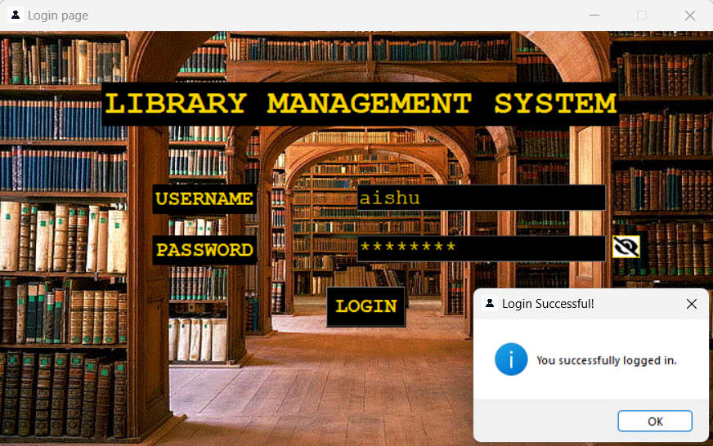

**2.MENU PAGE:**

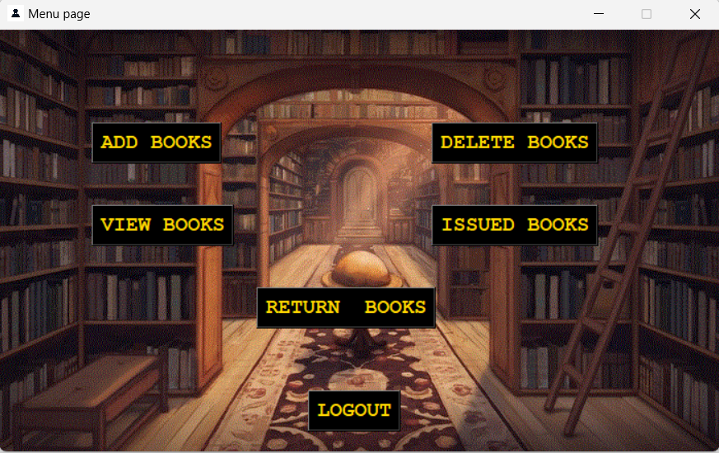

**3.ADD BOOKS:**

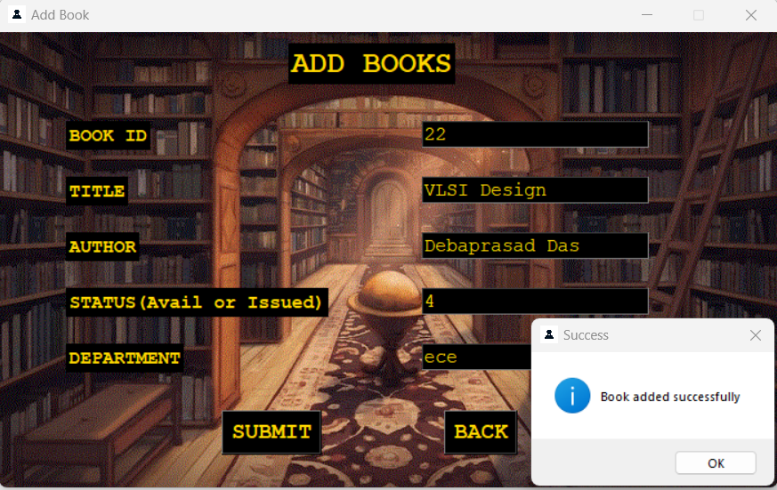

**4.SQL DATA:**

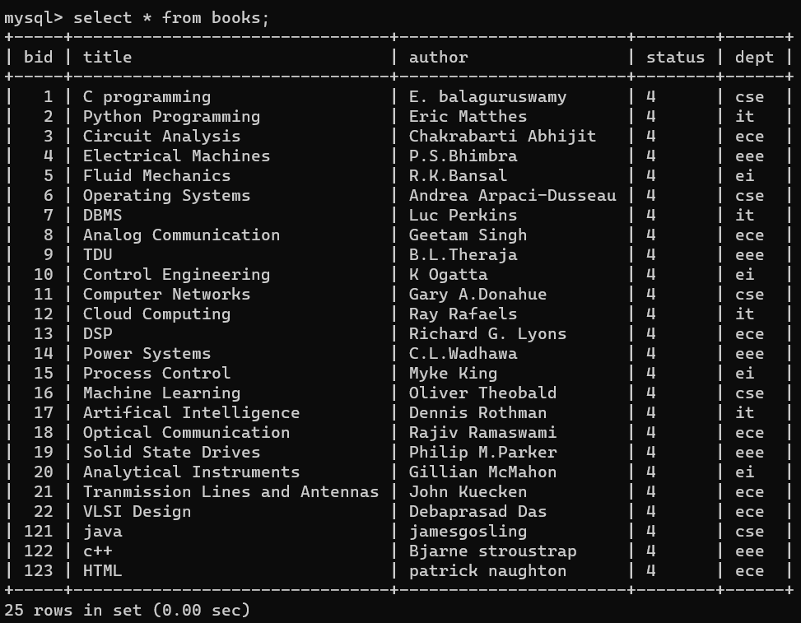

**5.VIEW BOOK:**

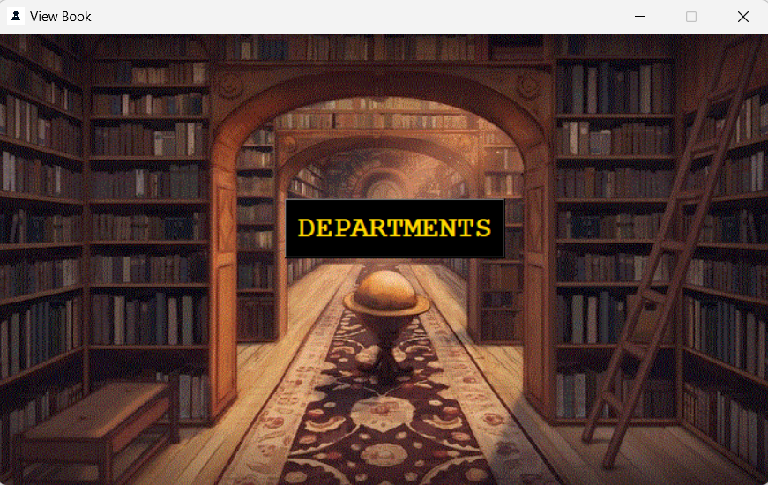

**6.DEPARTMENTS:**

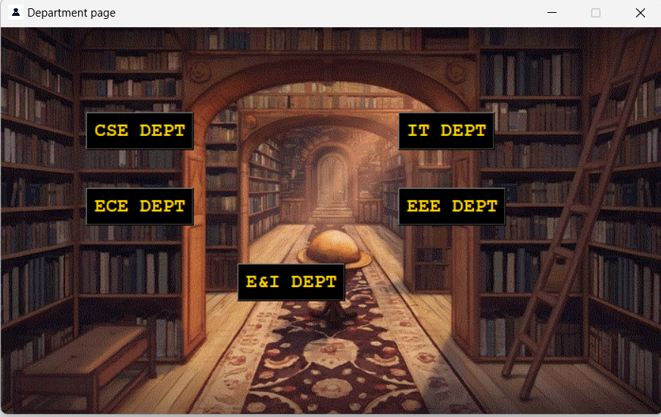

**7.SHOW BOOKS:**

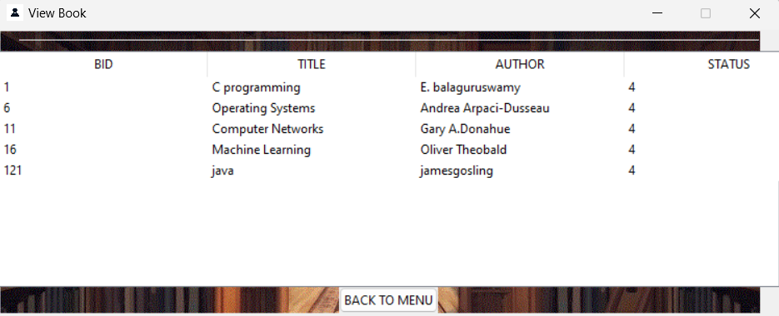

**8.ISSUE BOOKS:**

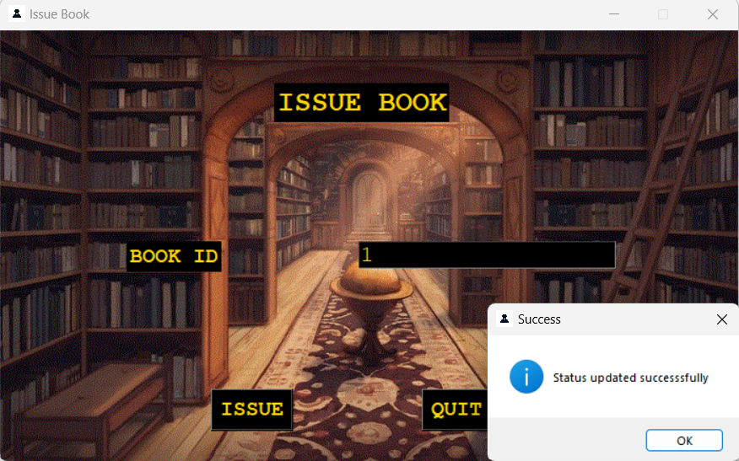

**9.SQL DATA:**

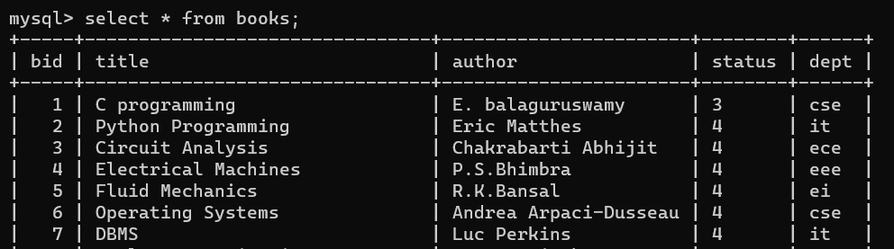

**10.RETURN BOOKS:**

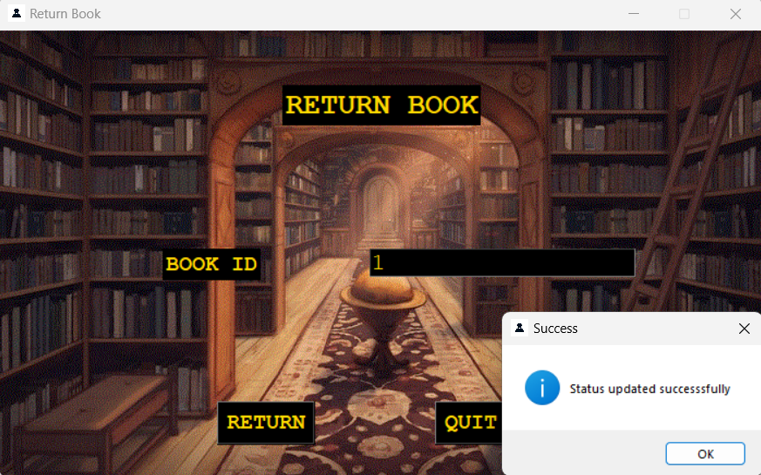

**11.SQL DATA:**

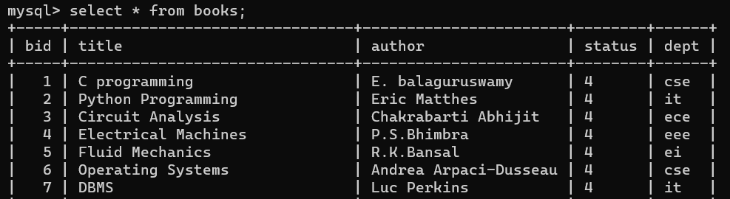

**12.DELETE BOOKS:**

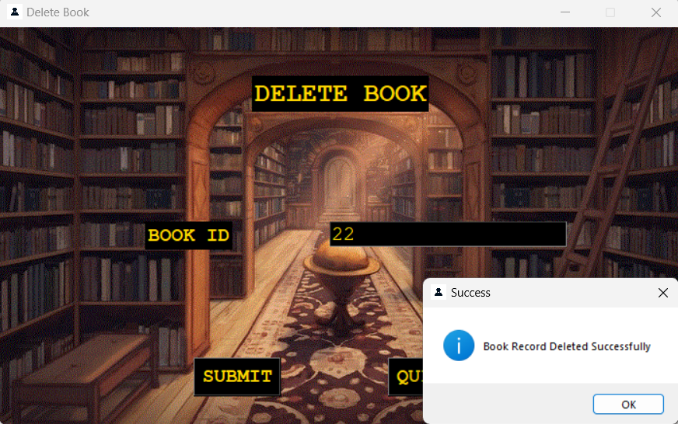

**13.SQL DATA:**

